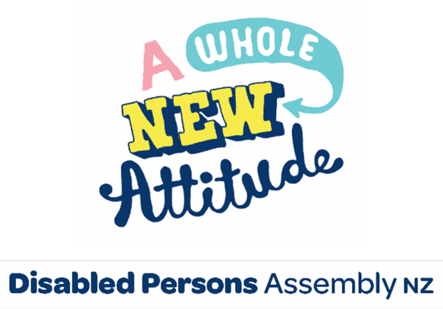

May 2024

Please find attached DPA’s submission on Corrections (Victim Protection) Amendment Bill.

Noho ora mai,

For any further inquiries, please contact:

Mojo Mathers

Chief Executive

Disabled Persons Assembly New Zealand

Email: [policy@dpa.org.nz](mailto:policy@dpa.org.nz)

# Introducing Disabled Persons Assembly

**We work on systemic change for the equity of disabled people**

Disabled Persons Assembly NZ (DPA) is a not-for-profit pan-impairment Disabled People’s Organisation run by and for disabled people.

We recognise:

* Māori as Tangata Whenua and [Te Tiriti o Waitangi](https://www.archives.govt.nz/discover-our-stories/the-treaty-of-waitangi) as the founding document of Aotearoa New Zealand;
* disabled people as experts on their own lives;
* the [Social Model of Disability](https://www.odi.govt.nz/guidance-and-resources/guidance-for-policy-makes/) as the guiding principle for interpreting disability and impairment;
* the [United Nations Convention on the Rights of Persons with Disabilities](https://www.un.org/development/desa/disabilities/convention-on-the-rights-of-persons-with-disabilities.html) as the basis for disabled people’s relationship with the State;
* the [New Zealand Disability Strategy](https://www.odi.govt.nz/nz-disability-strategy/) as Government agencies’ guide on disability issues; and
* the [Enabling Good Lives Principles](https://www.enablinggoodlives.co.nz/about-egl/egl-approach/principles/), [Whāia Te Ao Mārama: Māori Disability Action Plan](https://www.health.govt.nz/publication/whaia-te-ao-marama-2018-2022-maori-disability-action-plan), and [Faiva Ora: National Pasifika Disability Disability Plan](https://www.moh.govt.nz/notebook/nbbooks.nsf/0/5E544A3A23BEAECDCC2580FE007F7518/$file/faiva-ora-2016-2021-national-pasifika-disability-plan-feb17.pdf) as avenues to disabled people gaining greater choice and control over their lives and supports.

**We drive systemic change through:**

**Rangatiratanga | Leadership:** reflecting the collective voice of disabled people, locally, nationally and internationally.

**Pārongo me te tohutohu | Information and advice:** informing and advising on policies impacting on the lives of disabled people.

**Kōkiri | Advocacy:** supporting disabled people to have a voice, including a collective voice, in society.

**Aroturuki | Monitoring:** monitoring and giving feedback on existing laws, policies and practices about and relevant to disabled people.

# The submission

Tēnā koutou ki ngā tangata tika,

Ma wai ra e taurima

Te marae i waho nei?

Ma te tika, ma te pono

Me te aroha e

*Who will tend*

*To the marae here?*

*Truth, honesty*

*And love will.*

## Introduction

DPA supports this bill as we support greater protection for disabled victims of offences and disabled persons for whose benefit protection orders under the Family Violence Act 2018 are in place.

Statistics show that disabled people experience much higher rates of violence and abuse than non-disabled people[1] and disabled women experience higher rates of violence[2] than non-disabled women.

With an increase in mental stress amongst people facing higher living costs, disability funding cuts, reduction of Work and Income benefits, loss of employment and many other factors, there are real concerns that disabled people will face increased violence from partners, spouses or family members.[3]

On the International Disability Day of Mourning 2024, remembrance services were held for disabled people killed in New Zealand[4] to remember disabled people and children lost to violence.

1. Office of Disability Issues. (n.d.). *Violence against disabled people in New Zealand – new research* <https://www.odi.govt.nz/whats-happening/violence-against-disabled-people-in-new-zealand-new-research/>
2. Martin, H. (July 2021, 22). *Disabled people report higher rates of sexual, physical violence, new research shows.* Stuff website. <https://www.stuff.co.nz/national/health/300363035/disabled-people-report-higher-rates-of-sexual-physical-violence-new-research-shows>
3. Lee, N. (April 2024, 9). *Nicole Lee: Survivor and advocate for ending violence against women with disabilities.* World Health Organisation website. [Nicole Lee: Survivor and advocate for ending violence against women with disabilities (who.int)](https://www.who.int/news-room/feature-stories/detail/nicole-lee-survivor-and-advocate-for-ending-violence-against-women-with-disabilities)
4. Disability Day of Mourning. (n.d.) *Memorial Lists: International – New Zealand* [Location: New Zealand – Disability Day of Mourning (disability-memorial.org)](https://disability-memorial.org/category/location/new-zealand)